Logic Model

Overview Guide

Logic Model Overview & Examples

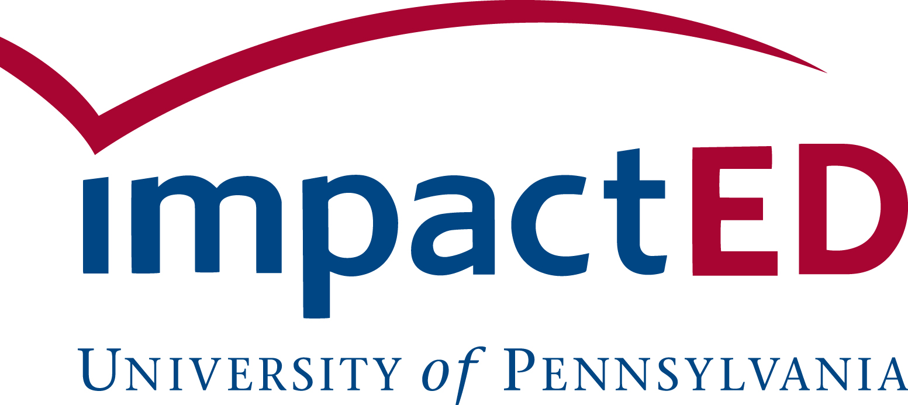


Overview

Purpose
This guide is designed to help organizations clearly define and communicate their program’s work through a logic model. A logic model is a simple tool that shows how a program’s resources, activities, and outcomes connect to its goals.

You can use this guide:
- To create or refine your program’s logic model, whether you are developing one for the first time or updating an existing version.
- To prepare for conversations with key stakeholders (e.g., participants, staff, funders) about your program’s intended impact and key components.

Resources
Below are a few companion tools you can use as you move through the guide:
- Logic Model Workshop Worksheet – to capture your initial ideas
- Logic Model Template (PowerPoint) – for your final logic model

Table of Contents
The guide includes a step-by-step walkthrough of the logic model components along with real-world examples from partner organizations:
Logic Model Components
Part 1: Intended Impact
Part 2: Implementation
Resources
Activities
Outputs
Part 3: Outcomes
Examples

Why Logic Models
“If you don’t know where you’re going, how are you going to know when you get there?” -Yogi Berra
Evaluation efforts should be about more than just collecting, analyzing and reporting on data. They should provide key stakeholders with data that can be used to inform strategic decisions, build a culture of continuous learning, and communicate with a diverse range of stakeholders about a program’s impact.
Logic models make this possible. A logic model provides a road map that articulates the key program activities and how they will lead to the desired results. It has multiple benefits:
Clarifies thinking on the program model and outcomes. A logic model serves as a planning tool to develop – and refine – a program’s strategy. A logic model helps organizations:
- Build their understanding of stakeholder needs and priorities
- Find gaps in the theory or logic of the program and work to address them
- Strategically prioritize the most important activities
- Creates a common language and alignment across staff
Serves as the foundation for evaluation efforts. A logic model can provide the foundation for evaluation work. A logic model helps organizations:
- Identify strategic evaluation questions of interest
- Prioritize data collection efforts that most align to strategic goals
- Develop a strategy for systematizing data collection and analysis
Stimulates learning and storytelling. A logic model provides information that can inform programmatic decisions and strategic communication efforts. A logic model helps organizations:
- Focus attention and resources on key priorities
- Build an internal culture of data use and continuous learning
- Clearly articulate the goals of the program and its impact to key external stakeholders

Logic Model Components
A logic model has three key parts:
- Part 1 - Intended Impact: What’s Your Why? Intended impact focuses on the specific population of individuals or communities served and the long-term impact you are working to achieve and will hold yourself accountable to.
- Part 2 - Implementation: What Will it Take? Planned work describes what resources you think you need to implement your program or project and what you plan to do.
- Part 3 - Outcomes: What Will Change? Outcomes capture the impact of your work over time (e.g., short-, medium-, and long-term) in service of the longer-term intended impact.

Part 1: Intended Impact
The intended impact focuses on WHO your program is serving by identifying the specific population of individuals or communities served, WHERE you work or the geography, and the long-term impact you are working to achieve and will hold yourself accountable to.
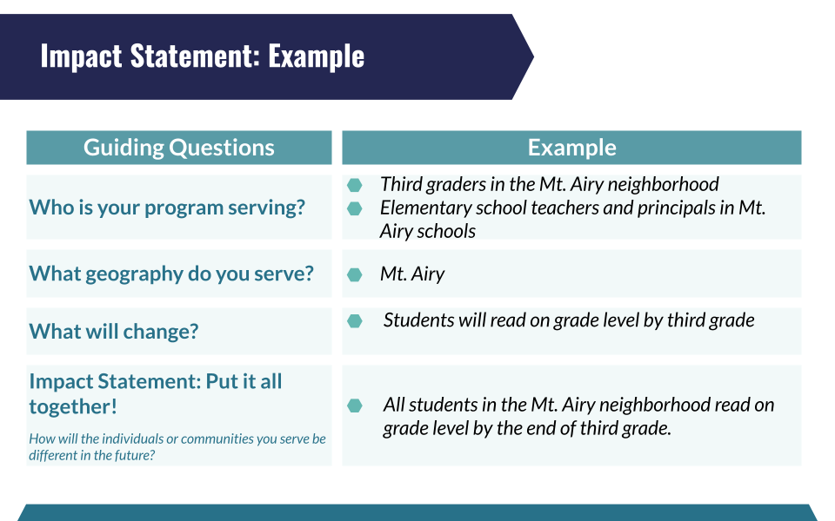
The intended impact statement often follows this type of format: “X population in Y geography will accomplish Z outcomes.”

Part 2: Implementation
IMPLEMENTATION describes what resources you think you need to implement your program and what you intend to do.
- Resources include the human, financial, organizational, and community resources a program has available to direct toward doing the work. Sometimes this component is referred to as Inputs.
- Activities are what the program does with the resources. Activities include the processes, tools, events, technology, and actions that are an intentional part of the program implementation. These activities are used to bring about the intended program changes or outcomes.
- Outputs are the direct products of program/project activities. They capture information on if the program is being implemented as intended and how it is being experienced by participants.

Resources
The resources, also known as inputs, in a logic model are the investments made to enable the program's work and achieve its goals. They can be divided into the following categories:
- Human Resources: Staff, volunteers, partners, and other human resources needed to execute the program.
- Material Resources: Space, technology, and other material resources needed to execute the program.
- Financial Resources: Sponsorships, grants, and other financial resources needed to execute the program.
- Knowledge Resources: Areas of expertise or experiences that are necessary to implement the program as designed.
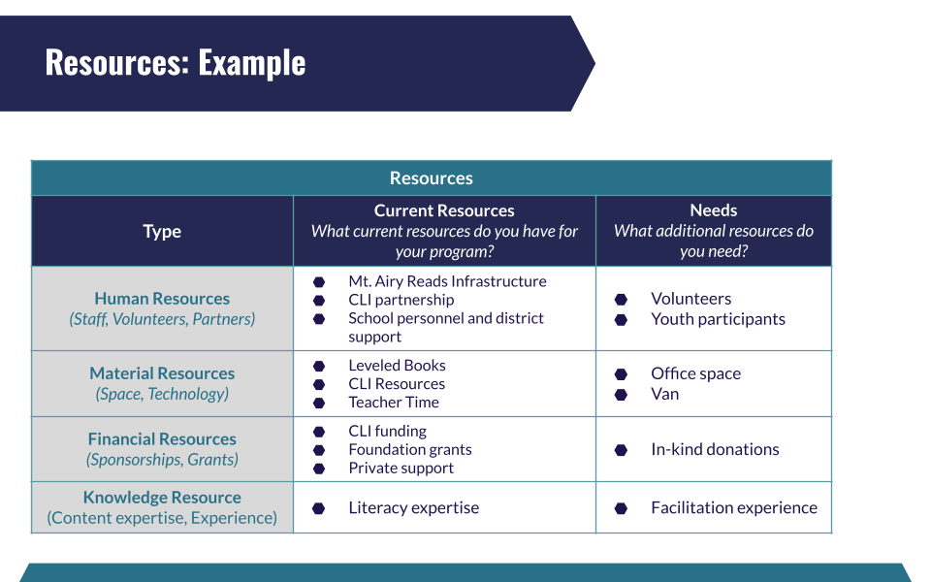

Activities
Activities describe what your program does with its resources. They include the specific actions, processes, and events that make up your work - i.e., the things your staff does to bring your program to life.
When identifying your activities, it can be helpful to organize them into categories that reflect the main strategies of your program, rather than listing every single task. For example, you might group activities into categories such as training and workshops, curriculum delivery, family engagement, or partnership development.
A well-structured set of activities should help tell the story of how your program operates and connect clearly to the outputs and outcomes that follow.

Outputs
Outputs are the direct and immediate products of your program’s activities. They help you track what you deliver and who you reach - for example, the number of participants served, sessions held, materials distributed, or events conducted.
Outputs demonstrate that your program is being implemented as intended and lay the foundation for assessing effectiveness by capturing information on program quality.
- Program Fidelity refers to the degree to which your program is implemented as designed. Maintaining fidelity helps ensure that the activities being carried out align with your program model and that you are delivering services consistently across sites or groups. Tracking fidelity may include monitoring adherence to core components, dosage (i.e., number of sessions delivered), and participant reach.
- Program Quality focuses on how well your program is implemented and the experience of participants. Quality measures might include participant satisfaction, staff preparedness, relationship-building, or engagement levels. Collecting feedback from participants and staff can provide valuable insight into areas of strength and opportunities for improvement.

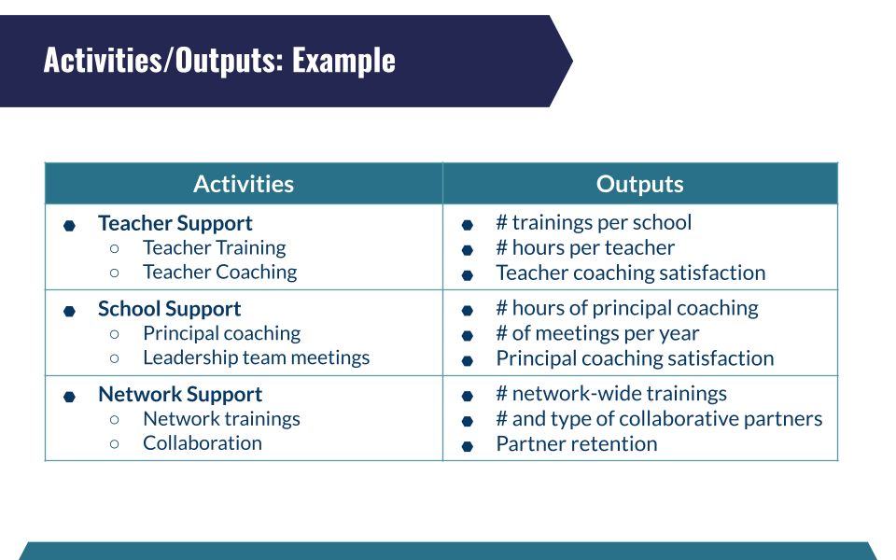

Part 3: Outcomes
OUTCOMES capture the impact of your work over time (i.e., short-, medium-, and long-term). They should be connected to your activities and be building towards your intended impact. It is likely that multiple activities work together to achieve your outcomes.
- Short-Term Outcomes: Short-term outcomes typically capture changes in knowledge, attitudes or awareness.
- Medium-Term Outcomes: Medium-term outcomes typically capture changes in skills, behaviors, and actions.
- Long-Term Outcomes: Long-term outcomes typically capture changes in status or condition.

When generating your outcomes, make sure they are the right level:
Right Level | More Detailed Than Needed (at this stage)
Increase reading level | - Percent of participants reading on grade level by 3rd grade
Improved instruction | - Percent of students who are making reading gains

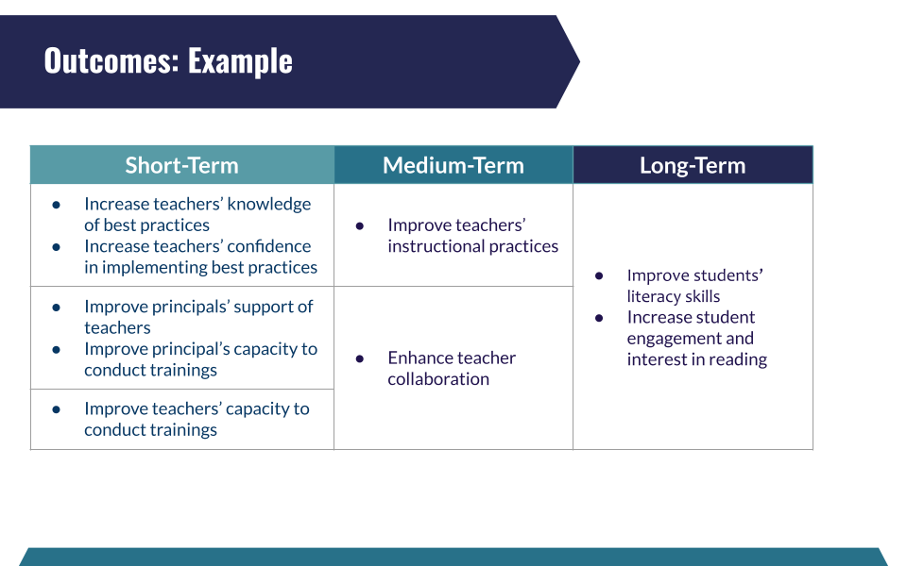

Key Considerations for Your Logic Model
The logic model can serve as a north star, clarifying the ultimate impact your program is seeking to achieve, and a strategic blueprint, outlining all the conditions that are needed to bring about that intended impact.
Reflection Questions: 3 P’s
Below are several considerations for finalizing your logic model.
Purpose (WHY): Does your logic model capture what matters most?
- Does your intended impact capture your ultimate outcome for those you serve (and not what you do)?
- Does the logic model identify - and clearly organize - the most important activities and outputs (i.e., program implementation & quality)?
- Do the short-term outcomes reflect progressive steps towards the most meaningful longer-term results?

People (WHO): Does your logic model reflect the needs/goals of those you serve?
- Does the logic model make clear who you are serving and reflect their values, preferences, and unique circumstances?
- Do staff have the resources and support they need to execute the activities as intended?

Process (HOW): HOW will you engage others in the logic model design process?
- How are you engaging a range of stakeholders in the logic model design process?

See a worksheet with these considerations to guide your review process.
Once you’ve reflected on these considerations, the ARC Method on the next page offers a simple, flexible approach for putting these principles into practice.

Engaging Stakeholders: ARC Method
An effective logic model reflects the perspectives and priorities of the people most connected to your work. Engaging stakeholders, such as staff, participants, partners, and community members, helps ensure your model is grounded in real experiences and shared goals.
The ARC Method offers a simple framework for meaningful engagement:
Accessible
- Meet people where they are (literally and figuratively). Create opportunities for input that are convenient, inclusive, and easy to participate in.
- Eliminate jargon or provide background information so everyone can engage with confidence and clarity.
Reciprocal
- Make participation a two-way exchange. Consider tangible incentives (e.g., gift cards, refreshments, or small tokens of appreciation).
- Communicate both the stakes and the potential benefits of the process so stakeholders understand how their input will be used and why it matters.
Creative
- Try approaches that are different or unexpected, like a gallery walk or hold an interactive session over a shared meal, to make the process engaging and enjoyable.
- Build in moments of reflection and celebration. Have fun with the process and use it as a way to strengthen relationships and shared understanding.

Examples

The Village of Arts & Humanities Logic Model
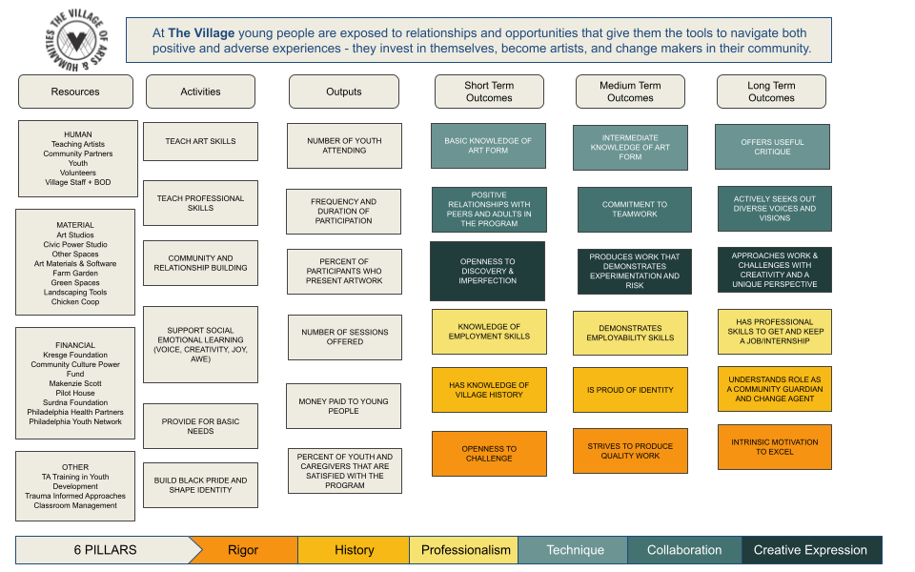

Turning Points for Children Logic Model

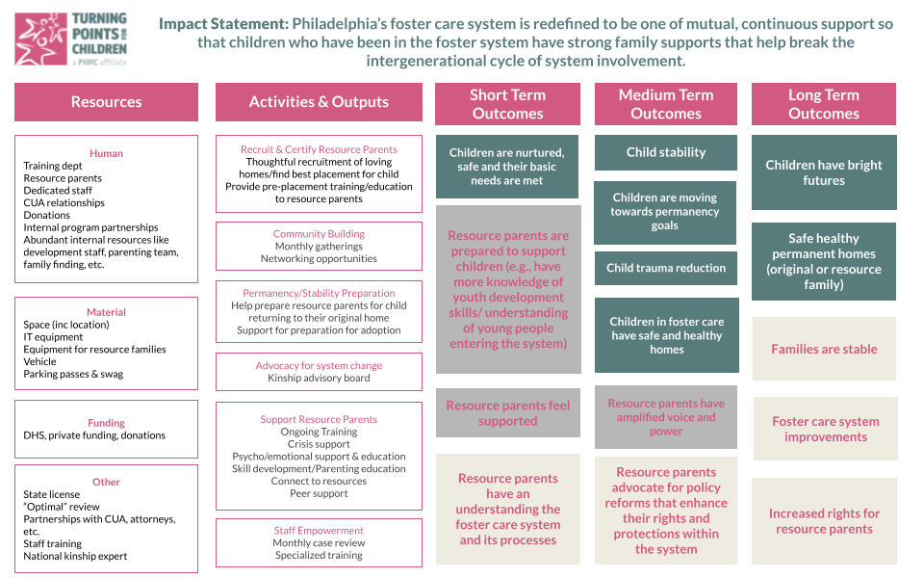

Mt. Airy Reads Initiative Logic Model
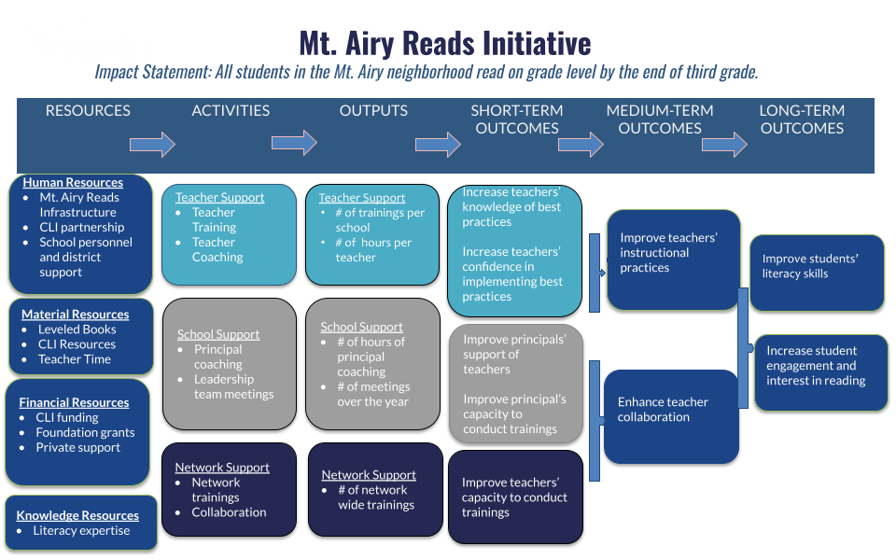

More Examples
See this database for additional logic model examples.

